Task 1: Project Setup and Introduction
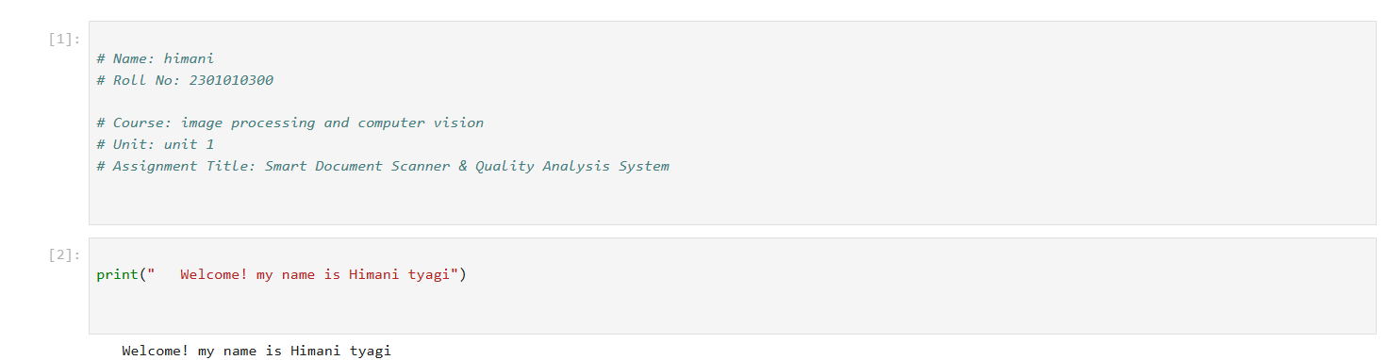

Task 2: Image Acquisition

import cv2
import matplotlib.pyplot as plt

# Load image
image = cv2.imread("doc.jpeg")

if image is None:
print("Image not found! Check filename.")
else:
# Resize image
resized = cv2.resize(image, (512, 512))

# Convert to grayscale
gray = cv2.cvtColor(resized, cv2.COLOR_BGR2GRAY)

# Show images
plt.figure(figsize=(10,5))

plt.subplot(1,2,1)
plt.title("Original Image")
plt.imshow(cv2.cvtColor(resized, cv2.COLOR_BGR2RGB))
plt.axis("off")

plt.subplot(1,2,2)
plt.title("Grayscale Image")
plt.imshow(gray, cmap="gray")
plt.axis("off")

plt.show()
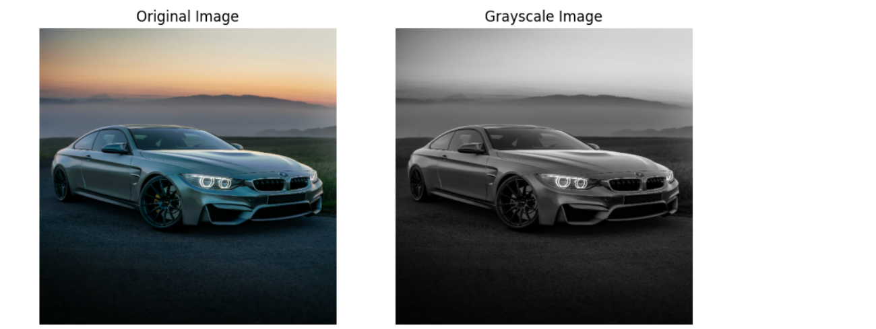

Task 3: Image Sampling (Resolution Analysis)

import cv2
import matplotlib.pyplot as plt

# Down-sampling
high = cv2.resize(gray, (512, 512))
medium = cv2.resize(gray, (256, 256))
low = cv2.resize(gray, (128, 128))

# Upscale back for viewing
medium_up = cv2.resize(medium, (512, 512))
low_up = cv2.resize(low, (512, 512))

# Display comparison
plt.figure(figsize=(12,6))

plt.subplot(1,3,1)
plt.title("High Resolution")
plt.imshow(high, cmap="gray")
plt.axis("off")

plt.subplot(1,3,2)
plt.title("Medium Resolution")
plt.imshow(medium_up, cmap="gray")
plt.axis("off")

plt.subplot(1,3,3)
plt.title("Low Resolution")
plt.imshow(low_up, cmap="gray")
plt.axis("off")

plt.show()
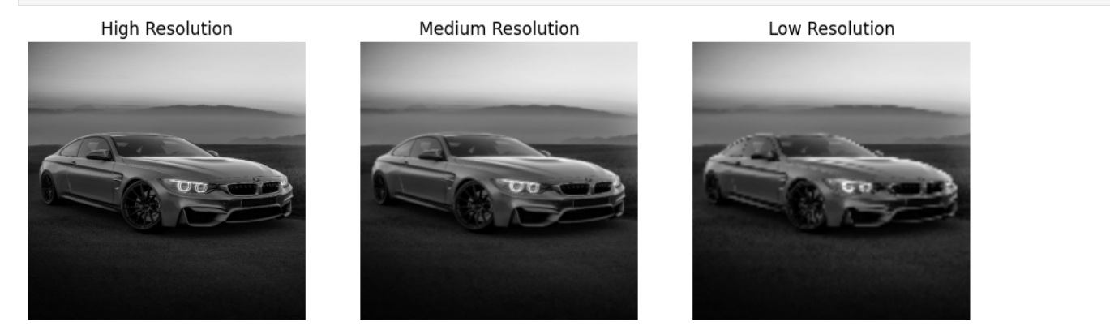

Task 4: Image Quantization (Gray Level Reduction)
import numpy as np
import matplotlib.pyplot as plt

# Quantization function
def quantize(img, levels):
return np.floor(img / (256 / levels)) * (256 / levels)

# Quantized images
q256 = quantize(gray, 256)
q16 = quantize(gray, 16)
q4 = quantize(gray, 4)

# Display results
plt.figure(figsize=(12,6))

plt.subplot(1,3,1)
plt.title("256 Gray Levels")
plt.imshow(q256, cmap="gray")
plt.axis("off")

plt.subplot(1,3,2)
plt.title("16 Gray Levels")
plt.imshow(q16, cmap="gray")
plt.axis("off")

plt.subplot(1,3,3)
plt.title("4 Gray Levels")
plt.imshow(q4, cmap="gray")
plt.axis("off")

plt.show()
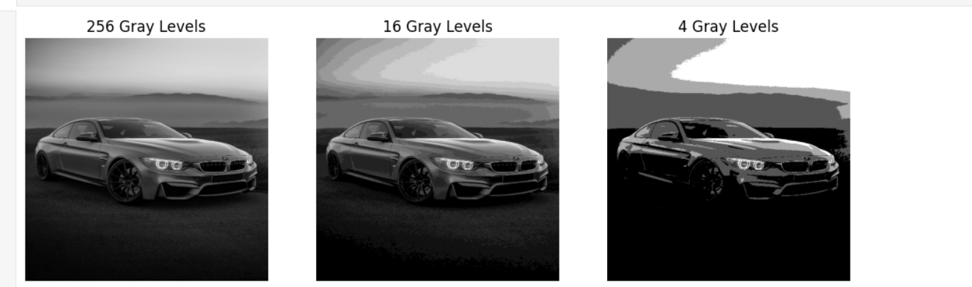

Task 5: Quality Observation & Analysis

import matplotlib.pyplot as plt

# Comparison figure
plt.figure(figsize=(14,8))

plt.subplot(2,3,1)
plt.title("High Resolution")
plt.imshow(high, cmap="gray")
plt.axis("off")

plt.subplot(2,3,2)
plt.title("Medium Resolution")
plt.imshow(medium_up, cmap="gray")
plt.axis("off")

plt.subplot(2,3,3)
plt.title("Low Resolution")
plt.imshow(low_up, cmap="gray")
plt.axis("off")

plt.subplot(2,3,4)
plt.title("16 Gray Levels")
plt.imshow(q16, cmap="gray")
plt.axis("off")

plt.subplot(2,3,5)
plt.title("4 Gray Levels")
plt.imshow(q4, cmap="gray")
plt.axis("off")

plt.show()

# Observations
print("\n--- Quality Observations ---\n")

print("1. Fine text details:")
print(" Lower resolution and heavy quantization remove thin strokes and edges.")

print("\n2. Readability:")
print(" Medium quality is readable, but low resolution and 4-level quantization")
print(" significantly reduce clarity.")

print("\n3. OCR suitability:")
print(" High resolution with full gray levels is best for OCR.")
print(" Degraded images increase recognition errors.")
